IMAT2207 Agile Team Development
Practical – Unit 9b

Building Your Allocated Component
Adding Validation
(Presentation Layer)
Creating the Presentation Layer 1
Before you Begin 1
Finish your GitHub Day 4

Creating the Presentation Layer

Before you Begin
Make sure that you have completed the work for last week and that you have watched the eLectures for this week before starting this work.

The final test of the validation functionality is to add a presentation layer to our work.
(Do I need to remind you to start your Git Hub day?)
You should already have a web form called AddressBookDataEntry.aspx…
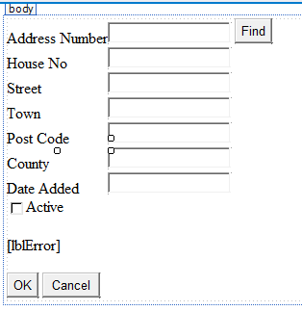

Double click the OK button to access the event handler for the control.

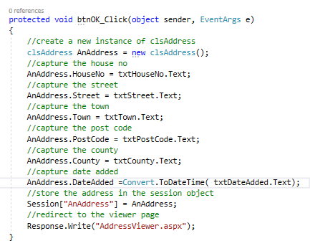

You should already have some existing code along the lines of this…

Modify this code so that it makes use of your validation method…
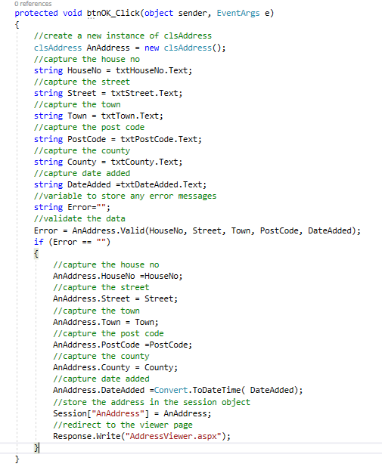
Notice how we now capture the inputted data to the string variables first and then pass these values to the validation method.

Lastly try the following code to add on some feedback to the user…
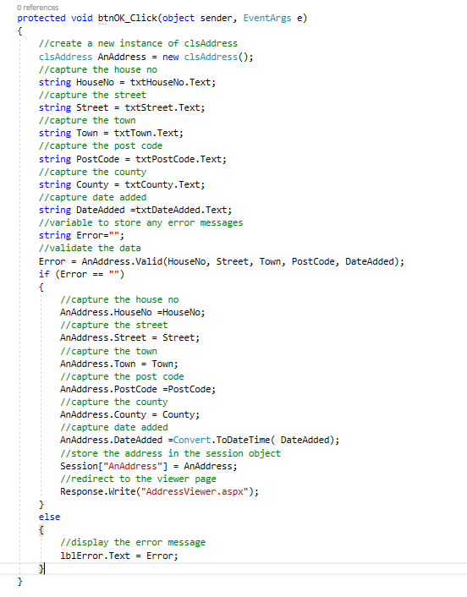
Run the application (remembering to add the AdminSystem as the Start Project and the Data Entry Page as the Start Page) and test out the feature with valid and invalid data to see if errors are trapped with the correct error messages.

For example:
- Click the OK button with no data in the control boxes
- Add dates that fall outside of your validation rules
- Exceed the number of characters required for each text box
- Add the minimum number of characters for each text box
- Add the correct number of characters for each text box.
You should see the error messages you created in the Valid function if the incorrect data is ‘added’ when you click the OK button.
Remember we don’t validate the primary key or the check box (Boolean).
Remember we are testing the validity of the data BEFORE it is passed to the database so you we don’t yet need the code for Add function.

At this point you may need to revisit your code if you think your validation needs tweaking.

Finish your GitHub Day
Lastly end your Git Hub day!
As usual, make sure your validation is correct and all code is working before merging your branch to the master.

